PRESS RELEASE
The 2-day hybrid Final Conference of the Cross-Border Project "Creative@Hubs" Interreg V-A Greece-Italy 2014-2020 was held with great success and participation, in Patras.
The Regional Development Fund of the Region of Western Greece implemented the Final Conference of the Creative@Hubs project of the European Territorial Cooperation Program "Interreg V-A Greece-Italy 2014-2020" on September 28-29, 2023, in the Amphitheater of the New Archaeological Museum of Patras.
During the 2-day event, specialist scientists and experts referred to the actions of the strategic project that had a duration of 4 years. The coordinators of the event were Mr. Stathis Papachristopoulos, Head of Unit A (Scientific-Technical Support) of RDF/RWG, and Mr. Takis Lybereas, Project Manager of the Creative@Hubs project.
Greetings were addressed by Mr. Fokionas Zaimis, Deputy Regional Director of Entrepreneurship, Research and Innovation of the RWG, Mr. Gianfranco Gadaleta, Coordinator of the Joint Secretariat of the Interreg V-A Greece-Italy Program 2014-2020 and Mrs. Tina Ranieri, Project Manager of the Joint Secretariat of the Interreg V-A Greece-Italy Program 2014-2020.
On the 1st day of the Conference, Mr. Lybereas referred to the general objectives and results of the project, making a general review of the actions implemented within the framework of the project, the impact the project had on the 4 participating Regions, but also to the actions that follow until its completion on November 30, 2023.
Followed by Mrs. Polyxeni Mantzou, Architect - Professor of the Department of Architectural Engineering at the University of Ioannina, who focused on the art of reviving Ioannina's craftsmanship using modern technology, thanks to Creative@Hubs.
The 3 Chambers of Commerce of RWG took the step with Mrs. Danai Katsanda (Achaia), Mr. Giorgos Robolas (Aetoloakarnania) and Mr. Dimitris Varelas (Ilia), to describe their involvement in the activities of the project as well as the results of these in the local communities. These actions included, among others, exchanges of know-how of hub managers, B2B networking missions, workshops-seminars, information and networking events, etc.
Mr. Andreas Tsiliras, Cultural Manager of MOSAIC and Hub Manager of the Achaia Creative Hub, focused on Innovation in the cultural and creative sector, while Mr. Sotiris Michalopoulos, Representative of CTI "Diofantos", referred to ICT Tools for supporting the local creative ecosystem, that were developed thanks to Creative@Hubs project. Mr. Vasilis Avdikos, Associate Professor at Panteion University – Department of Social and Political Sciences, presented the Evaluation and Sustainability Plan of the Creative@Hubs project, with a description of the introduction of Creative Hubs into local/regional development strategies and agendas.
The keynote speaker of the Final Conference was the Professor of Marketing of the Department of Balkan Slavic and Oriental Studies of the University of Macedonia, Mr. Anastasios Panopoulos, who made an excellent statement on the importance of innovation in communication, as a good practice to be adopted by the cultural and creative industry sector.
The 2nd day of the Conference focused on the effects of Creative Hubs on self-employment and small businesses. The day started with 26 B2B meetings of missions of small and medium enterprises, creators, artists and organizations of the cultural and creative sector, from Greece and Italy.
On the part of the Apulia Region, Mr. Antonio Stasi, Professor at the University of Foggia, Francesco Notarangelo, CIHEAM Bari | KU Youth Entrepreneurship and Innovation Ecosystems and Maria Elena Latino, Assistant Professor at the Innovation Engineering Department of the University of Salento, respectively, developed the following topics: "Combining creativity with rural development in Puglia Region", "Hub Model, Open Innovation and Living Lab" and "Methodologies and technologies to enliven living lab: the metaverse and rural living lab experiences".
The Conference concluded with the presentation of research and studies of the Panteion University – Department of Social and Political Sciences, with the following topics:
- "Social and environmental impacts of Collaborative Workspaces; The CORAL Index" (Mr. Lorenzo Marmo)
- "Collaborative Workspaces and Social Innovation Processes in Rural Areas; A Comparison between Greece and Austria" (Mr. Colm Stockdale)
- "Local creative ecosystems, employability and the role of hubs" (Mrs. Antigoni Papageorgiou)
- "Collaborative Workspaces in non-urban areas: new (e)quality workplaces for women? Insights from Austria and Greece" (Mrs. Alexandra Wrbka).
The Creative@Hubs – Interreg V-A Greece-Italy project involves four partners: Region of Western Greece – Regional Development Fund (lead), Region of Epirus, Region of Ionian Islands and Region of Apulia. In the context of a programmatic agreement with the Region of Western Greece, the following partners also participate: CTI "DIOFANTOS", the three Chambers of Commerce of the Region of Western Greece (Aetoloakarnania, Achaia, Helia) and the Institute of Regional Development - Panteion University.
For more information, visit the project website: https://2014-2020.greece-italy.eu/rlb-funded-projects/creativehubs/
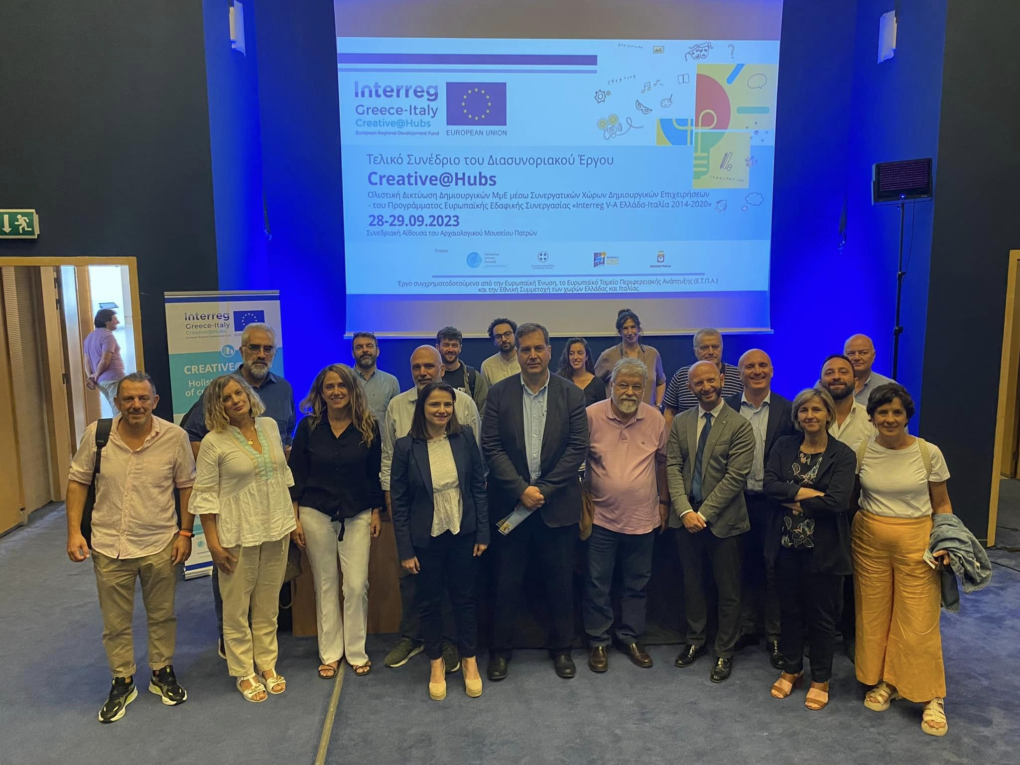

For more information, please contact the following email: (tlybereas@ptapde.gr)
Project web site: https://2014-2020.greece-italy.eu/rlb-funded-projects/creativehubs/
Joint Secretariat Communication Officer
Contact person: Mrs Carmela Sfregola, Tel: +39 3493916007
email: c.sfregola@greece-italy.eu
www.greece-italy.eu
Interreg V-A Greece-Italy Programme is a European Territorial Cooperation Programme that aims to help public institutions and local stakeholders to develop cross-border projects and pilot actions and to create new policy, products and services, with the final goal to improve the citizens’ quality of life.
Strategically, the programme will enhance innovation in a number of fields such as blue growth, tourism and culture, agro-food and cultural and creative industries. Interreg V-A Greece-Italy Programme aims to get maximum return from EUR 123 million financed per 85% by European Regional Development Fund (ERDF) and per 15% by the 2 member states through a national co-financing.

